Functional Design Document



**Prepared for:** STAKBANK

**Document Version:** 2.0

**Date:** 04 Apr 2021

**Prepared by:** Bao Hoang

Use of Document

This document will be used for signing off as a Business Requirements Document.

Document Control

|  |  |  |  |
| --- | --- | --- | --- |
| **Version** | **Date** | **Name** | **Comments** |
| 1.0 | 04 Apr 2021 | Bao Hoang | Initial Version |
| 1.1 | 12 Apr 2021 | Thuong Vu | Added Item 3.5 |
| 2.0 | 27 Apr 2021 | Thuong Vu | - Distribute STAK in reward instead of JSTAK - Remove Conversion screen |
|  |  |  |  |
|  |  |  |  |
|  |  |  |  |
|  |  |  |  |
|  |  |  |  |
|  |  |  |  |

1. Introduction

1.1. Document Purpose

The Functional Design Document is intended to serve as a guide for the development and configuration of the Stakbank. This FDD focuses on all project deliverables, inputs and outputs associated with each process function. This FDD also outlines functional and non-functional requirements within the scope of the project.

1.2. Intended Audience

This document is designed for the stakeholders to understand the background, meaning and in-depth functionalities of the proposed solution to be signed off. This document is also intended for:

1. Project Sponsor
2. Business Owner
3. Business Analysts
4. Project Managers
5. System Architect
6. Development Lead
7. Quality Assurance Team
8. Support Team

1.3. Scope of Work

The below table details the main products to be provided by Stakbank

|  |  |  |
| --- | --- | --- |
| **SN** | **System** | **Required (Yes / No)** |
| 1 | STAK staking | Yes |
| 2 | STAK un-staking | Yes |
| 3 | STAK claiming | Yes |
| 4 | STAK compounding | Yes |
| 5 | Farms | Yes |
|  |  |  |

Below table details the services to be provided

|  |  |  |
| --- | --- | --- |
| **SN** | **Scope of Services** | **Required (Yes / No)** |
| 1 | Project Management | Yes |
| 2 | Solution Design | Yes |
| 3 | Quality Control | Yes |
| 4 | Training | No |
| 5 | User Acceptance Test | Yes |
| 6 | Onsite Standby | No |
| 7 | Customer Automation Services | No |
| 8 | Database Migration | No |
| 9 | Creative Design Services | No |
| 10 | Post Live Support based on SLA | No |
| 11 | Hosting Web and Data | No |

2. Document Scope

This section defines the project scope and deliverables.

2.1. Attributes of Individual Requirements

For each identified requirement, the following items of information are represented in a tabular format:

|  |  |  |
| --- | --- | --- |
| **Requirement ID** | : | A unique identifier for the requirement. |
| **Priority** | : | The priority level of the requirement. |
| **Phase** | : | To implement in which phase |

The requirement is then described in detail, with any associated non-functional and interface requirements separately identified.

2.2. Priority of Requirements

Within this document, all requirements are categorized under 3 priority levels:

|  |  |  |
| --- | --- | --- |
| **Value** | **Priority** | **Description** |
| 1 | Essential | This requirement is critical for the system to work and for operations to continue as normal. This is of the highest priority. |
| 2 | Highly Desirable | This requirement may prove extremely useful for the system to work more efficiently. This is of medium priority and may not be delivered on the deadline of the project. However, it will be implemented in the next immediate possible iteration of the project cycle. |
| 3 | Desirable | This requirement could prove useful in enhancing the system. This is of the lowest priority and may not be delivered on the deadline of the project. However, it may be implemented during the enhancement phase of the project cycle. |

3. Functional Requirement

3.1. MicroServices to Cloud platform

As the demand for the website increase, therefore MicroServices need to execute on the cloud platform.

There are several cloud platforms like AppScale, Cloud Foundry, OpenShift, OpenStack and so on.

These cloud platforms provide scalable web services and distributed database systems.

We need to deploy MicroServices to the cloud platform to meet the demands of traffic.

So it is important to decide the cloud platform which micro service will be executed.

Once the specified cloud platform is selected, we can make the micro service using platform SDKs and deploy it to the cloud via console or UI.

3.2. Security

**3.2.1 Micro Service Security**

It is important to secure the website and micro services.

In general, cloud platforms provide node security. So we need to secure the service apis.

The following figure shows how to build service security.

Website

Micro Service 1

(AppScale)

Micro Service 2

(Cloud Fundry)

Micro Service 3

(OpenStack)

…

Deployed Private Key

Access Forbidden.

No Deployed Private Key

We deploy private key to the website and micro services and update the deployed private key periodically.

MicroServices accept request which contains the crypto information related to the deployed private key and rejects all the other.

Like this, we can implement microservice security.

**3.2.2. Database Security**

Cloud platforms provide their own Database Management System, so we can easily use it to design database. But these databases are not secure.

In the project, there are some important tables such as payment table.

So we have to assess the secure level to the tables and save them into different databases.

|  |  |  |
| --- | --- | --- |
| **Secure Level** | **Tables** | **Description** |
| 1 | Personal Information  Payment Information | These tables require high security level and the data must be encrypted. Here, the speed is not important. It might be saved in specified database node. |
| 2 | Transaction Information  Booked Lessons  ….  (Progress tables) | These tables require medium security level and the data might be encrypted. It requires medium speed. Tables might be saved in the cloud databases. |
| 3 | Job Information  Lesson Information  Schedule Information  … | These tables does not require high security level but high speed. It doesn’t require encryption. It might be changed by attacker but this doesn’t affect the main website.  It can be saved in the cloud databases. |

3.1. Stakbank Home

As a guest of Stakbank, I need to connect to a wallet to stake, unstake and claim reward.

|  |  |  |  |
| --- | --- | --- | --- |
| **Req. ID** | **Priority** | **User Story** | **Description / Remarks** |
| FR-STAKBANK-HOME-001 | 1 | View Home screen | **What are the fields that the Home screen includes?** |
| * The Home screen includes the following functionalities:   + Total reward pool   + STAK to harvest   + Your staked: The number of STAK staked to system * A user needs to connect to a wallet to use those functionalities. | | | |

3.1.1. Wallet Connection

As a user of Stakbank, I need to connect my wallet to use full functions supported by the Stakbank

|  |  |  |  |
| --- | --- | --- | --- |
| **Req. ID** | **Priority** | **User Story** | **Description / Remarks** |
| FR-STAKBANK-HOME-002 | 1 | Connect to wallet | **How can a user connect to his wallet?** |
|  | | | |

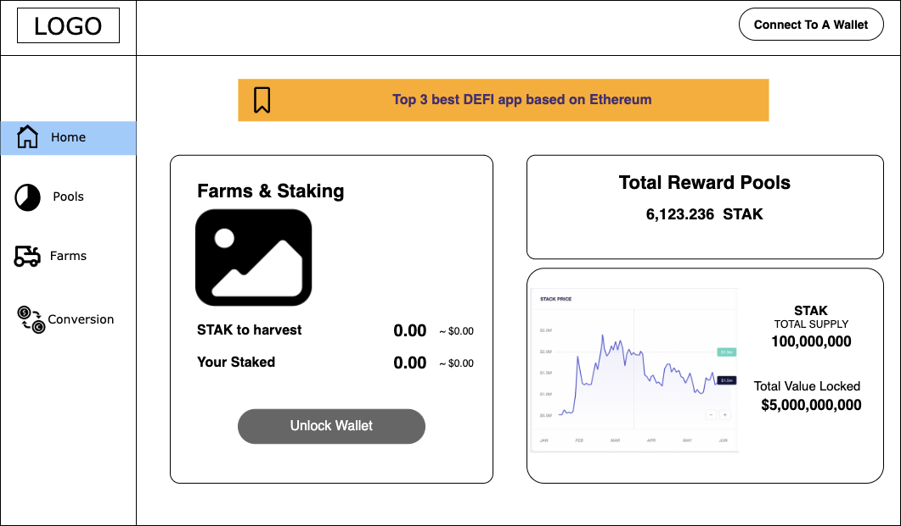

3.2. Pool

As a user of Stakbank, I can view the Pool screen

|  |  |  |  |
| --- | --- | --- | --- |
| Req. ID | Priority | User Story | Description / Remarks |
| FR-STAK-POOL-001 | 1 | View pool | A user can view the Pool screen |
| * Pool screen contains two main components:   + STAK Pool:     - Your reward:       * The user’s reward in STAK     - Total staked     - Total reward pool     - Claim: A user press this button to claim reward     - Compound: A user press this button to compound his reward into his current staking   + Your position:     - Your Staked: Current staking STAK     - APY: Annual Percentage Yield (%) which indicates the rate at which the deposit account can earn money     - Stake STAK: A user press this button to stake STAK     - Unstake STAK: A user press this button to unstake STAK   **Acceptance Criteria:**   * To claim reward, compound, stake, and unstake STAK, a user must:   + Connect his wallet   + Approve STAK | | | |

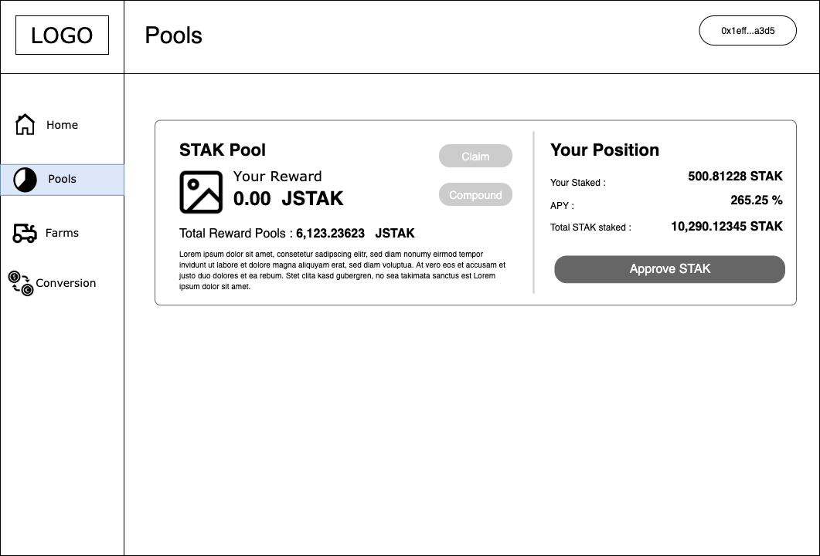

3.2.1. Approval

As a user of Stakbank, after connecting my wallet, I need to approve Stakbank to withdraw my STAK from my wallet and automate transactions for me.

|  |  |  |  |
| --- | --- | --- | --- |
| Req. ID | Priority | User Story | Description / Remarks |
| FR-STAK-POOL-002 | 1 | Approve Stakbank | Approve Stakbank to withdraw STAK from a user’s wallet and automate transactions. |
| * A user needs to approve Stakbank to withdraw STAK from his wallet and automate transactions * When a user approves, he would be directed to the wallet interface for the approval process.   **Acceptance Criteria:**   * This step is available when a user has connected his wallet on Stakbank successfully. | | | |

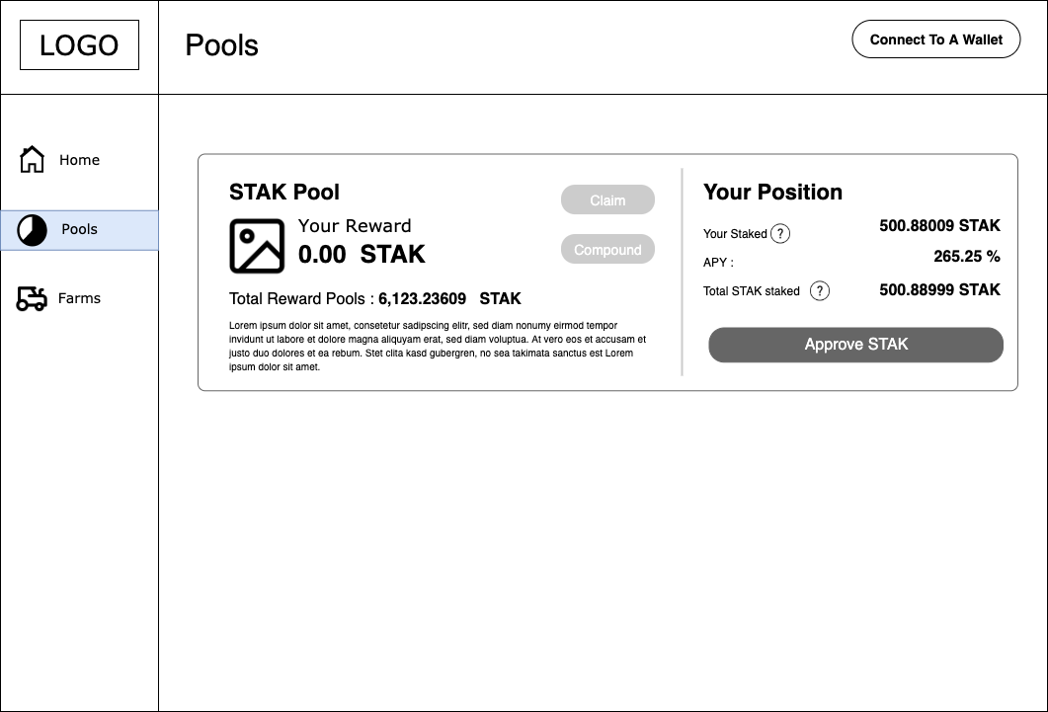

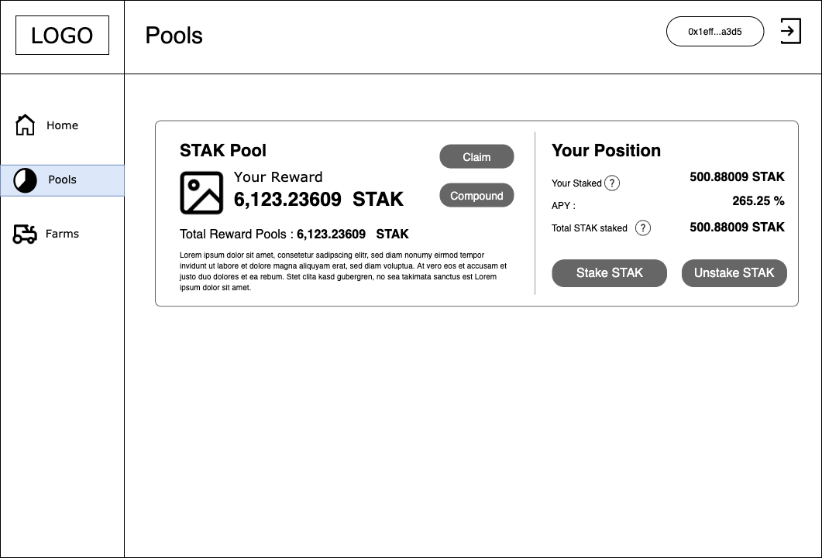

3.2.3. Staking

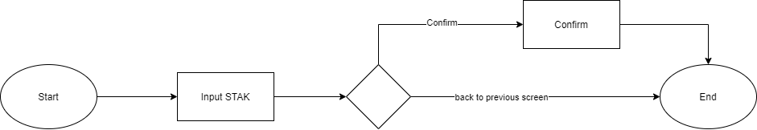

***Staking***

As a user of Stakbank, I can stake STAK tokens to the staking pool.

|  |  |  |  |
| --- | --- | --- | --- |
| **Req. ID** | **Priority** | **User Story** | **Description / Remarks** |
| FR-STAK-POOL-003 | 1 | STAK Staking | **How can a user stake STAK to the staking pool?** |
| In general, a user stakes STAK to the staking pool for passive income. At the end of a day (which is supposed to be at 21:00 PST), he will receive a reward which is calculated based on the APY. Is the APY going to be published somewhere, how can it change? How is the Smart Contract informed of the change?  Our assumption that the reward will be distributed to users once per day. The APY is just for estimation number only that means it is not exactly the amount of reward. We have the APY Formula, it will be changed accordingly to the STAK price, price and quantity of LP are staking in the pool.   If you have another thought please provide     * When user press the ‘Stake STAK’ button, a popup is invoked which includes:   + Balance: Current STAK a user has. If the inputted STAK is greater than the balance, Stakbank does not allow a user to stake.   + Input field: A user inputs his STAK. Note that Stakbank only supports staking by STAK.   + Minimum amount STAK: defined by JigStack DAO Council.   + Max button: to fill the maximum balance into the input field   + ‘Stake STAK’ button | | | |

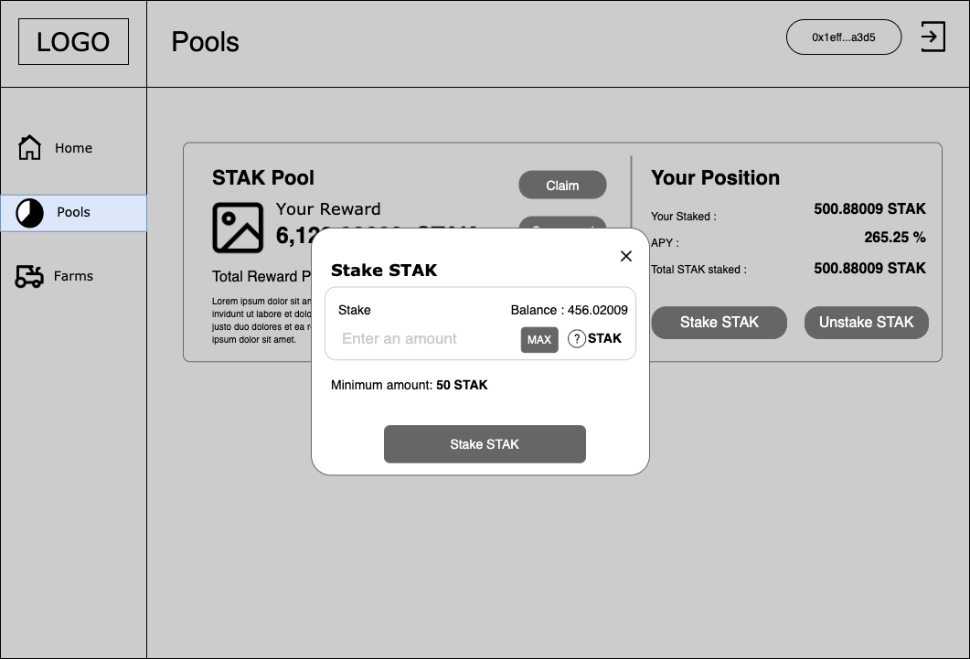

3.2.3. Unstaking

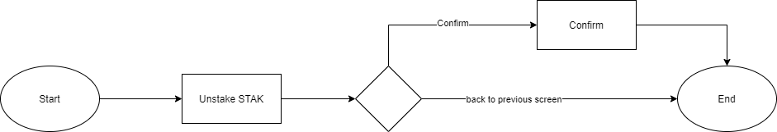

***Unstaking***

As a user of Stakbank, I can unstake STAK from the staking pool.

|  |  |  |  |
| --- | --- | --- | --- |
| **Req. ID** | **Priority** | **User Story** | **Description / Remarks** |
| FR-STAK-POOL-004 | 1 | STAK Unstaking | **How can a user unstake STAK from the staking pool?** |
| When user press the ‘Unstake STAK’ button, a popup is invoked which includes:   * Balance:   + Current STAK a user has * Input field: A user inputs the amount of STAK he wants to unstake. If the inputted STAK is greater than the current staking STAK, Stakbank does not allow a user to unstake. * Your staked: current staking STAK * ‘Unstake STAK’ button * Max button: to fill all the staking amount in the input field * A user receives JSTAK | | | |

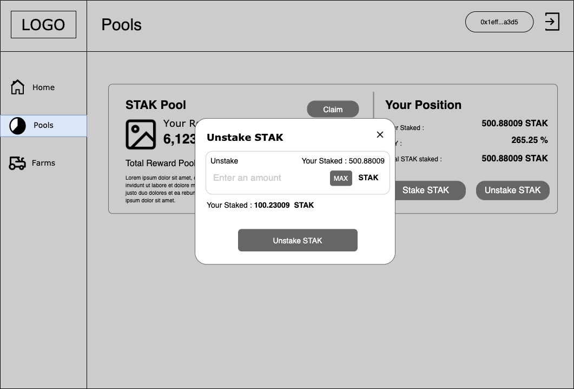

3.2.4. Compound

As a user of Stakbank, I can compound my reward into my current staking STAK.

|  |  |  |  |
| --- | --- | --- | --- |
| **Req. ID** | **Priority** | **User Story** | **Description / Remarks** |
| FR-STAK-POOL-005 | 1 | STAK Unstaking | **How can a user unstake STAK from the staking pool?** |
| In general, a user compounds his current reward to increase his current staking STAK to earn more incentives. When user press the ‘Compound’ button, a popup is invoked which includes:   * Your reward:   + A user’s current reward in STAK * ‘Compound’ button   **Acceptance Criteria:**   * Current reward must greater than 0 JSTAK | | | |

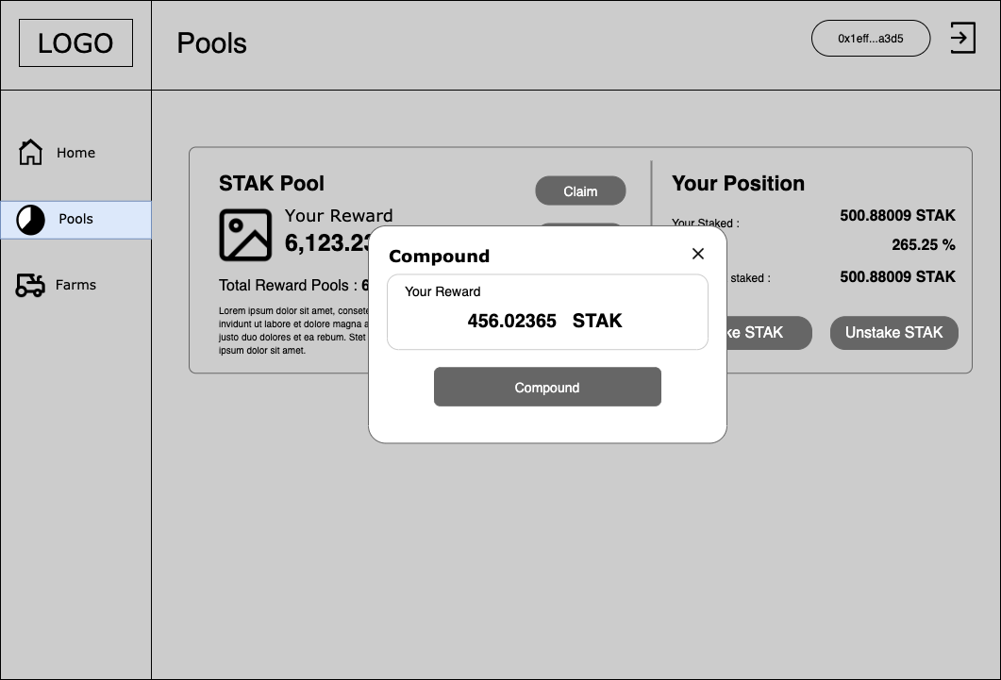

3.2.5. Claiming

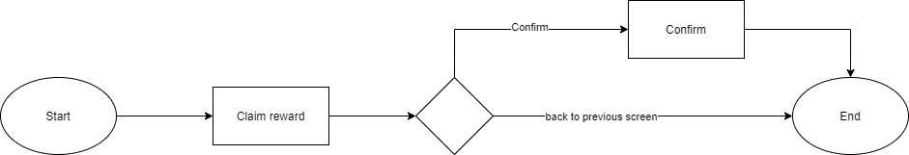

***Claiming***

As a user of Stakbank, I can claim reward in STAK from the staking pool.

|  |  |  |  |
| --- | --- | --- | --- |
| **Req. ID** | **Priority** | **User Story** | **Description / Remarks** |
| FR-STAK-POOL-006 | 1 | STAK Claiming | **How can a user claim reward from the staking pool?** |
| At the end of a day (which is supposed to be at 21:00 PST), he will receive a reward in JSTAK which is calculated based on the APY.  When user press the ‘Claim’ button, a popup is invoked which includes:   * Current reward in STAK * Confirm claiming popup * A user receives JSTAK | | | |

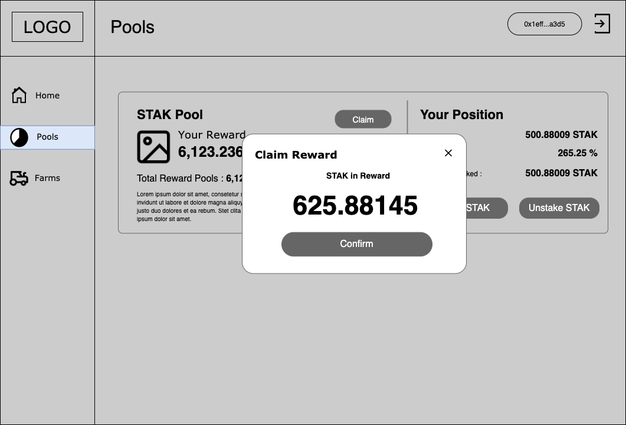

3.3. Farms

As a user of Stakbank, I can view the Farms screen

|  |  |  |  |
| --- | --- | --- | --- |
| Req. ID | Priority | User Story | Description / Remarks |
| FR-STAK-FARM-001 | 1 | View farms | A user can view the Farm screen |
| * Pool screen contains:   + STAK - ETH LP token pool:     - STAK earned: in STAK and USD fiat currency     - Stake LP Tokens: A user presses this button to stake LP tokens     - Unstake LP Tokens: A user presses this button to unstake LP tokens     - Harvest: A user press this button to receive STAK as reward   + Your position:     - Get STAK-ETH LP Tokens: A user presses this button to be directed to UNISWAP for generating LP tokens     - Your LP Staked: Current staking LP     - APY: Annual Percentage Yield (%) which indicates the rate at which the deposit account can earn money     - Total Staked: in USD fiat currency   **Acceptance Criteria:**   * To harvest, compound, stake, and unstake LP tokens, a user must:   + Connect his wallet   + Approve LP tokens: Approve Stakbank to withdraw LP tokens from a user’s wallet and automate transactions.   + Approval flow is similar to section 3.2.1 | | | |

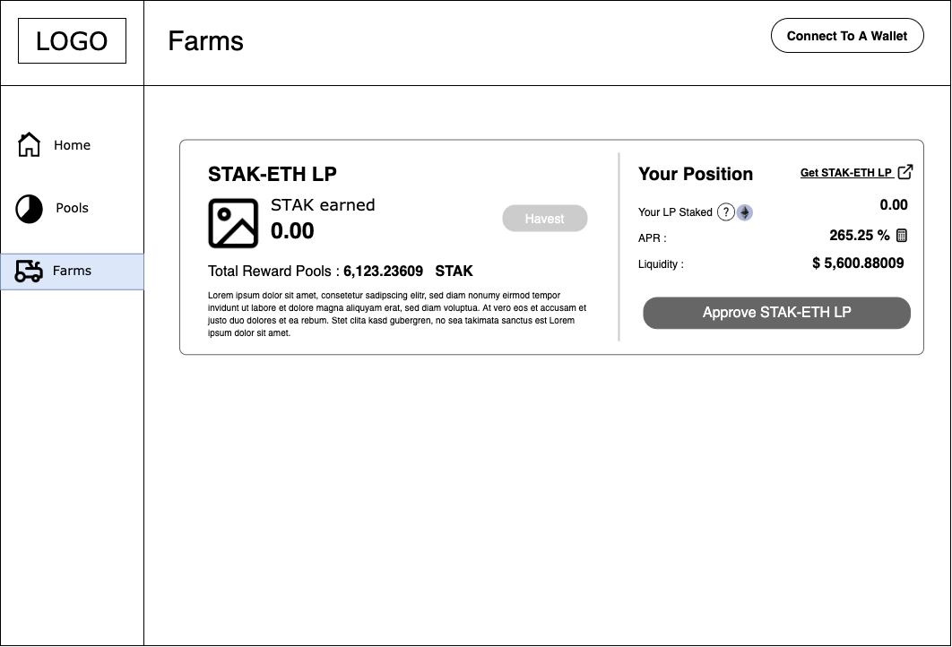

3.3.1. LP Staking

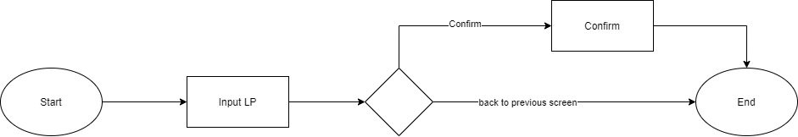

***Staking LP tokens***

As a user of Stakbank, I can stake LP tokens to the staking pool.

|  |  |  |  |
| --- | --- | --- | --- |
| **Req. ID** | **Priority** | **User Story** | **Description / Remarks** |
| FR-STAK-FARM-002 | 1 | LP Staking | **How can a user stake LP to the staking pool?** |
| In general, a user stakes LP to the staking pool for passive income. At the end of a day (which is supposed to be at 21:00 PST), he will receive a reward in STAK which is calculated based on the APY.  Stakbank does not support generating LP tokens. Instead, a user must use UNISWAP for generating STAK-ETH LP tokens.   * When user press the ‘Stake LP Tokens’ button, a popup is invoked which includes:   + Balance: Current LP tokens a user has. If the inputted LP tokens is greater than the balance, Stakbank does not allow a user to stake.   + Input field: A user inputs his LP tokens.   + Get STAK-ETH LP Tokens: A user presses this button to be directed to UNISWAP for generating the LP tokens   + Max: User presses this button to stake all his LP tokens.   + ‘Stake LP tokens’ button | | | |

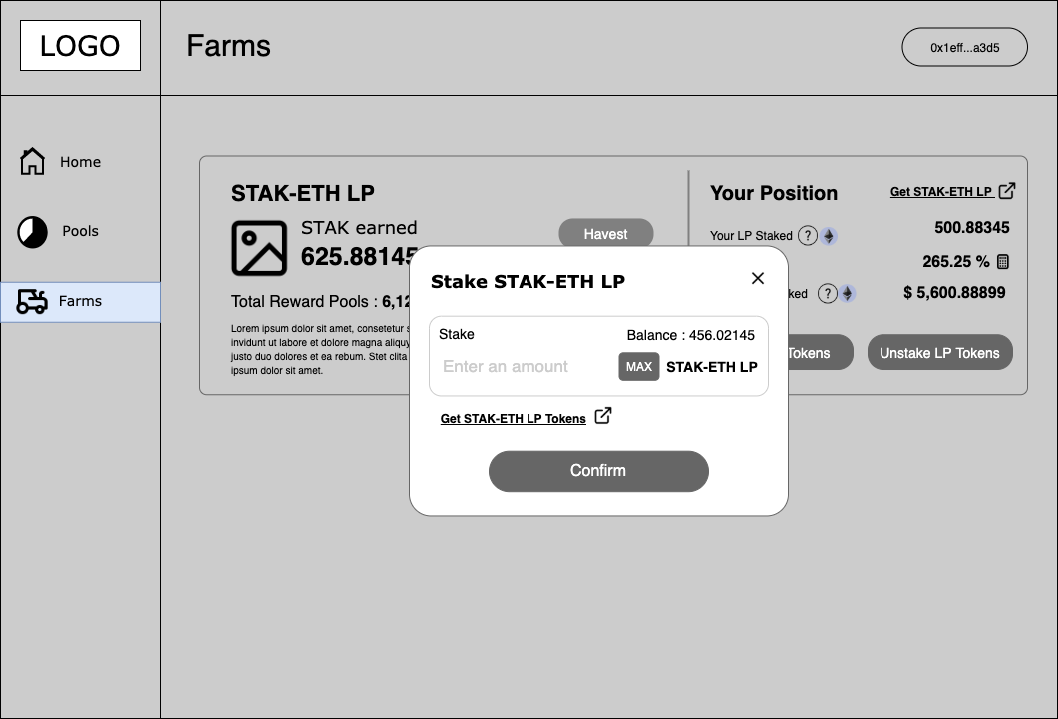

3.3.2. LP Unstaking

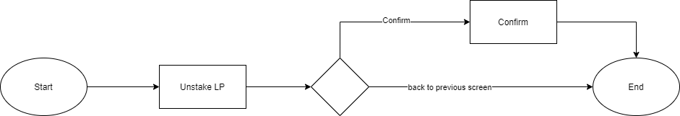

***LP Unstaking***

As a user of Stakbank, I can unstake LP tokens from the staking pool.

|  |  |  |  |
| --- | --- | --- | --- |
| **Req. ID** | **Priority** | **User Story** | **Description / Remarks** |
| FR-STAK-FARM-003 | 1 | LP Unstaking | **How can a user unstake LP tokens from the staking pool?** |
| When user press the ‘Unstake LP tokens’ button, a popup is invoked which includes:   * Balance:   + Current LP tokens a user has. * Input field: A user inputs the amount of LP tokens he wants to unstake. If the inputted LP tokens is greater than the current staking LP, Stakbank does not allow a user to unstake. * Your staked: current staking LP tokens * Max: User presses this button to unstake all his LP tokens. * ‘Unstake LP tokens’ button * A user receives JSTAK when unstakes his LP tokens | | | |

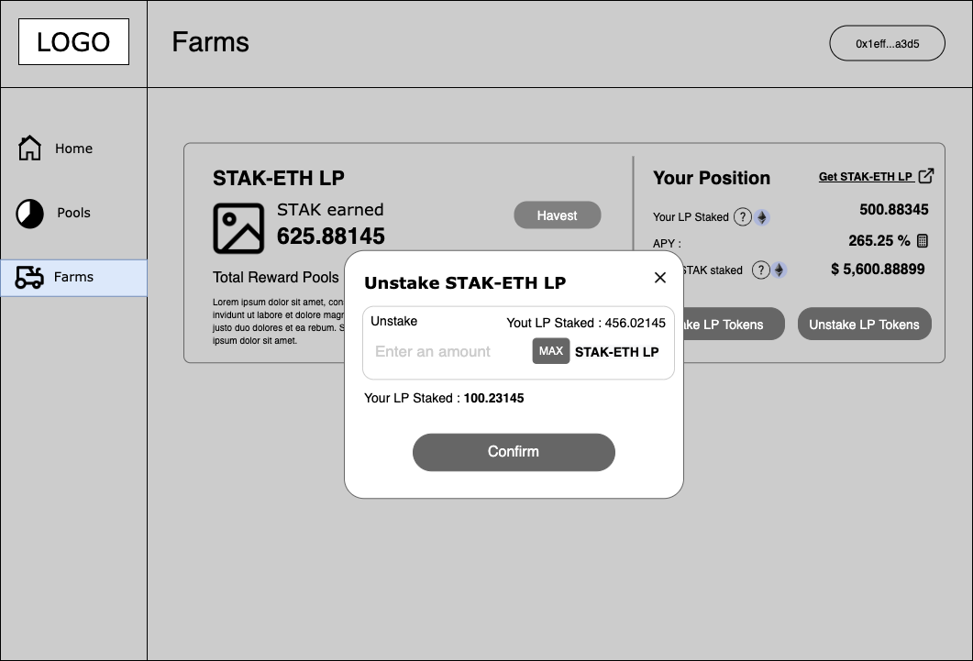

3.2.3. LP Harvesting

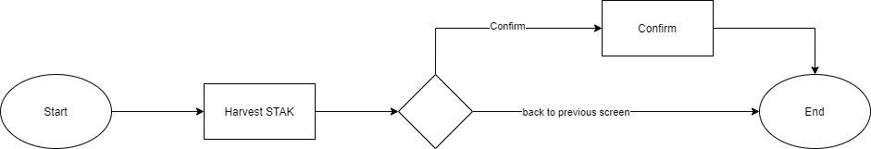

***LP harvesting***

As a user of Stakbank, I can harvest in STAK from the staking pool.

|  |  |  |  |
| --- | --- | --- | --- |
| **Req. ID** | **Priority** | **User Story** | **Description / Remarks** |
| FR-STAK-POOL-004 | 1 | STAK Claiming | **How can a user claim reward from the staking pool?** |
| At the end of a day (which is supposed to be at 21:00 PST), he will receive a reward in JSTAK which is calculated based on the APY.  Note that when a user harvests, he receives reward in STAK.  When user press the ‘Harvest’ button, a popup is invoked which includes:   * Balance:   + Current reward LP tokens a user has * Current reward (in both STAK, JSTAK and USD fiat currency) * ‘Harvest’ button * A user will receive JSTAK | | | |

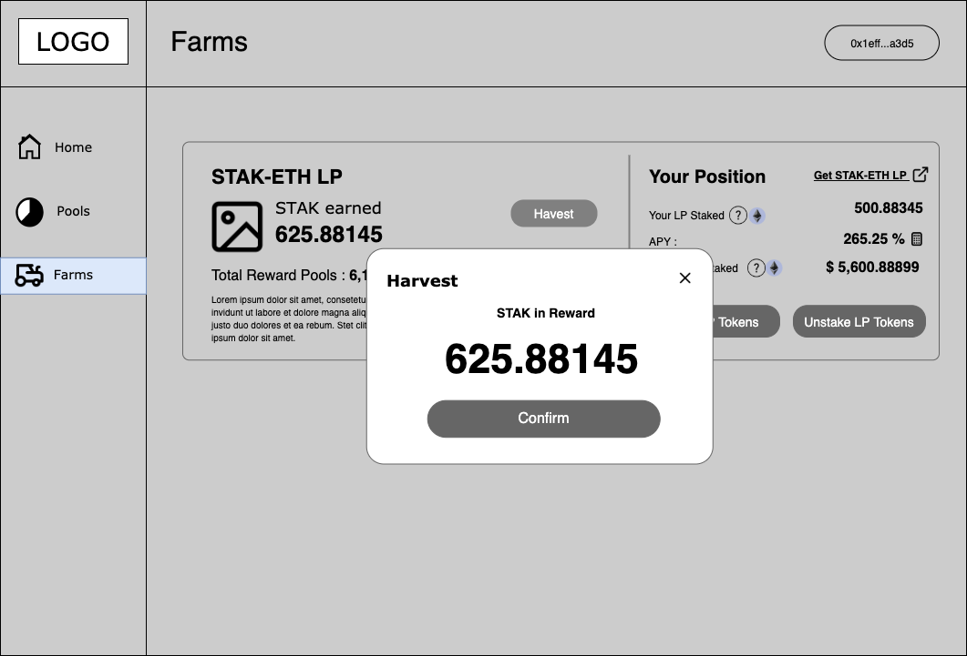

3.2.4. APY

As a user of Stakbank, I can view APY.

|  |  |  |  |
| --- | --- | --- | --- |
| **Req. ID** | **Priority** | **User Story** | **Description / Remarks** |
| FR-STAK-POOL-005 | 1 | View APY | **A user can view APY information** |
| APY screen includes:   * Timeframe: in days * APY (%)  * STAK per 1,000 USD * Get STAK-ETH LP Tokens: A user presses this button to be directed to UNISWAP for generating the LP tokens | | | |

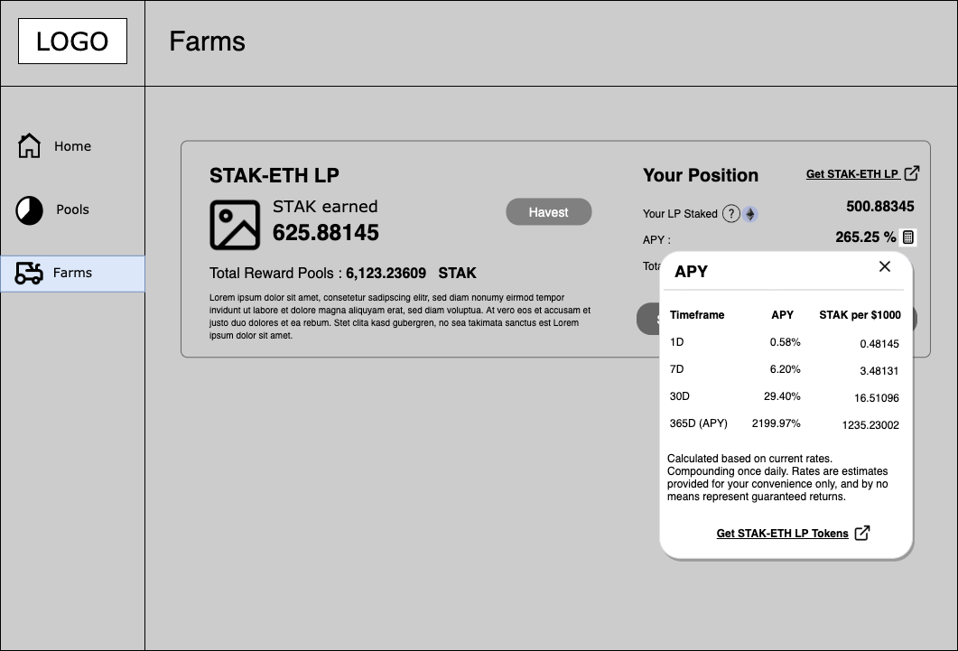

3.5 Flow Chart

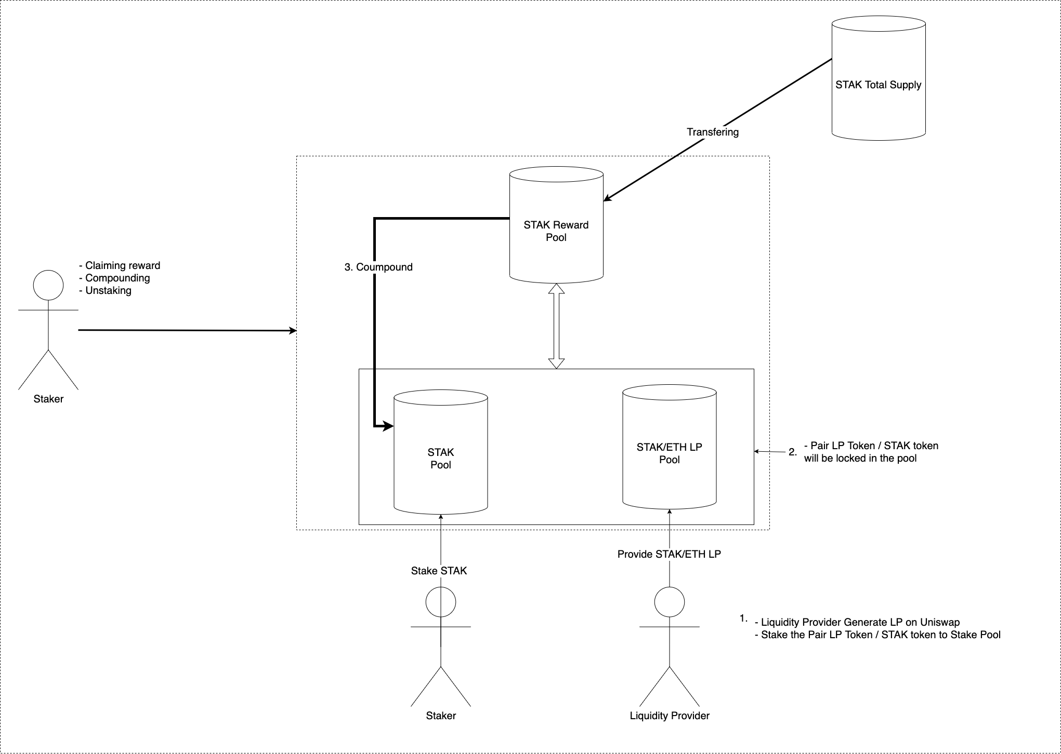

Description:

1. Users get the Pair LP Token from Uniswap
2. User stake/provide STAK/ Pair LP to stakbank system to start Staking/Farming
3. To compound the reward into the principal amount
4. Staker/LP Locker have options:
   1. Claim reward
   2. Compound STAK to staking amount
   3. Unstake
   4. Stake

Below is the flow describes how a User can create Liquidity on Uniswap:

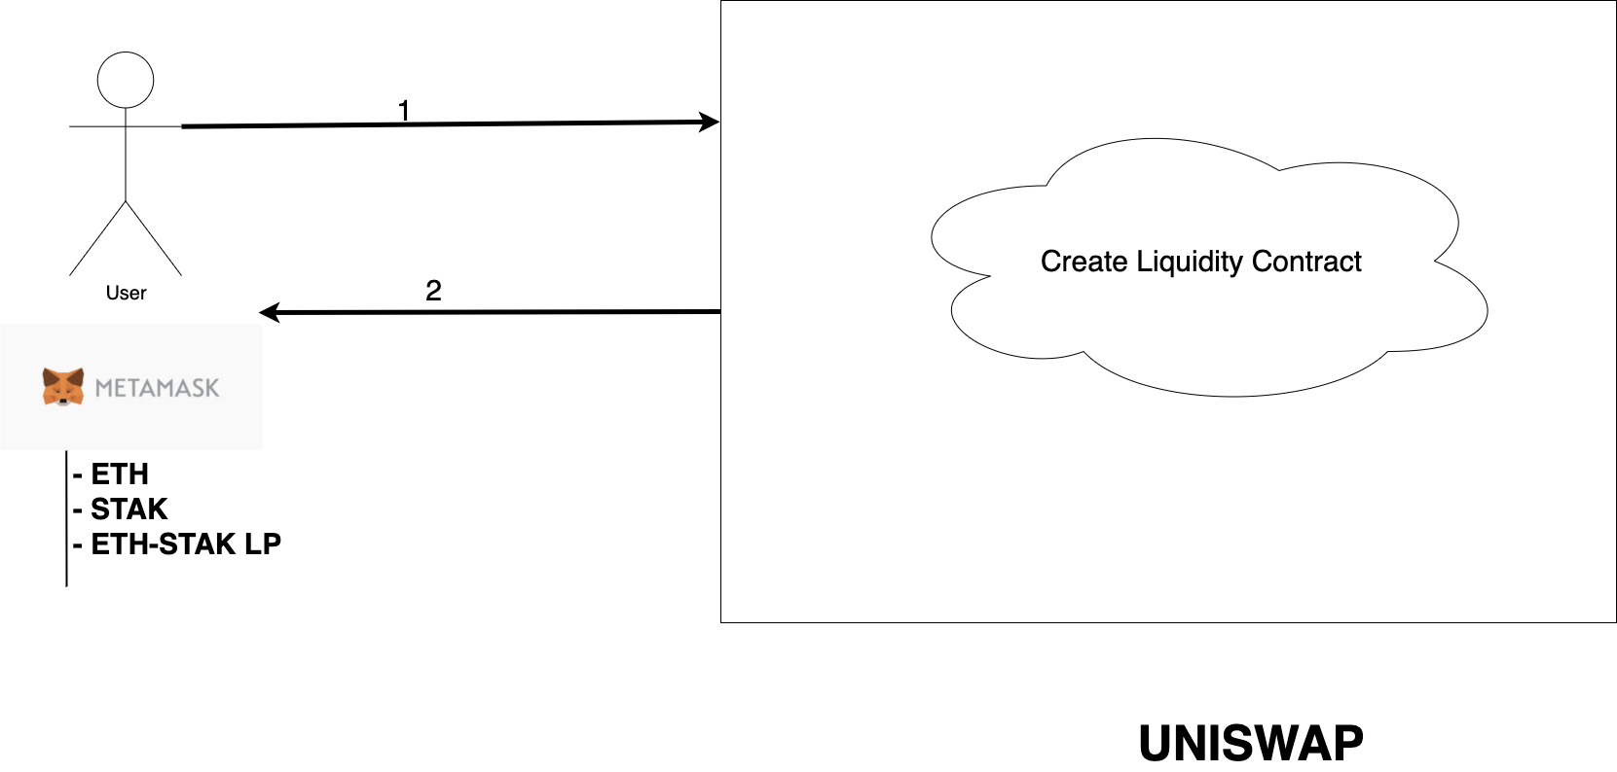

1. User should have ETH and STAK token in metamask wallet, then he can enter the Uniswap (<https://app.uniswap.org/#/create/ETH>) platform then select Create a Pair option. Ex: ETH and STAK tokens.
2. After the flow, Uniswap will return the Pair LP token back to the user's metamask wallet. Then he can go to the Stakbank system and start the farms.

3.6 Formula

3.6.1 APY

**Calculate ROI of a pool**

STAK_PER_YEAR = DISTRIBUTION_PERCENTAGE_A_DAY * BALANCE_OF_REWARD_POOL * 365

FORMULA: ROI (1y) = ( allocPoint / totalAllocPoint ) * 100 * STAK_PER_YEAR * STAK_PRICE / (slpBalance * reserveUSD / totalSupply) * 100

=> ROI (1m) = ROI(1y) / 12

=> ROI (1d) = ROI(1y) / 365

allocPoint the weight number of each pool which is configurable

**How to calculate STAK per day in the Yield Per $1000 column ?**

FORMULA: r

STAK_PER_DAY = DISTRIBUTION_PERCENTAGE_A_DAY * BALANCE_OF_REWARD_POOL

STAK_IN_DOLLAR = STAK_PER_DAY * STAK_PRICE

STAK_PER_DAY_YIELD_$1000 = STAK_PER_DAY / STAK_IN_DOLLAR * 1000 * ROI (1y) / 365 * 100

**Annual Percentage Yield**

APY = ROI(y)

4. Acknowledgement

|  |  |  |
| --- | --- | --- |
| **CLIENT APPROVAL** | | |
| **Approved By:** | **Position:** | **Date:** |
| *[Pls. sign over printed name]* |  |  |